August/
September 2023
Contents
- Contacts; Pocklington Area Open Studios
- Bugthorpe School
- Bishop Wilton Show
- Bishop Wilton Shop
- Beck & Bells; Rainfall
- Bishop Wilton Hall
- Fleece Inn Golf
- Bishop Wilton School
- Church News
- Friendship Group
- Church Services
- Bishop Wilton WI;
Coronation Morning by
Ruth Mardall
- Table Tennis
- Clever solutions by Vicki Kress
- Bishop Wilton PC

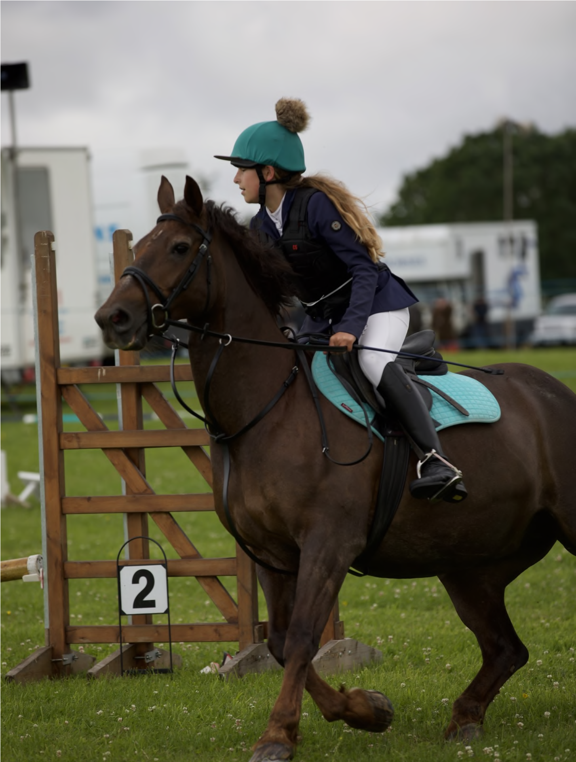
Village Newsletter for Bishop Wilton and the Garrowby Parishes

Photo by Allan Wilkinson
One of the riders at Bishop Wilton Show.
Full report and more photographs on pages 4-5

Contacts

Bishop Wilton Parish Council
Following the recent election your new Parish Councillors are:
Phil Warry, Chair, mob 07392 157755 philwarrybwcouncil@gmail.com
Ingrid Hayward, Vice-Chair ingrid1862@gmail.com

Stewart Berry
Jo Denton jodenton2012@gmail.com
John Miles, mob 07976 932977 johnmilesbwpc@gmail.com
Ashlea North anorthbwcouncil@gmail.com
Iain Rickatson irickatsonbwcouncil@aol.com
Paul Rigby paulrigbybwpc@gmail.com
Roy Sumpner 01759 368617 r.s.technic@clara.net
Sandra Morrison, Clerk to the PC bishopwiltonclerk@gmail.com
Tel 01262 470496

Bishop Wilton Defibrillator (located on the outside wall of The Village Hall) Cabinet code: C0147X Police (non emergency): 101 Village Hall Bookings: 01759 368813
Bus Services: 01482 592929 Doctors’ Surgeries:

Pocklington 302500 Fax 305123 Stamford Bridge 371467
Bishop Wilton Oil Syndicate : Contact Maureen McWilliam www.bishopwiltonoil@gmail.com Websites:
www.bishopwiltonshow.com (show) www.bishopwiltonprimaryschool.co.uk www.bishopwiltonhall.co.uk (Hall)

To submit articles for the Parish Pump contact: Frances Sharp, email: bwparishpump@gmail.com
To advertise, contact: Liz Collins, email: collins.wilton@gmail.com
Deadline for submissions for October/
November issue is 15 September 2023

Pocklington Area Open Studios

Saturday 7th & Sunday 8th October 2023
Preparations are well underway for Pocklington Area Open Studios which is taking place on the weekend of 7th & 8th October. 28 artists & makers will be taking part at 14 different locations within 10 miles of Pocklington including some in the Parish Pump area.
Ceramics, textiles, photography, jewellery, painting, printmaking &
mixed media will be on display. This Open Studios weekend is a great opportunity to meet local artists & makers, see their latest work and learn about their creative processes. Venues will be open 10 – 5 both days and will be clearly signed. Some venues will be doing demonstrations & some will also be offering refreshments. Full details can be found on the website www.pocklingtonareaopenstudios.co.uk.
Brochures will be available from the venues & at other locations in the area. More information can also be found on Facebook – pockareaopenstudios and Instagram - @pocklingtonareaopenstudios

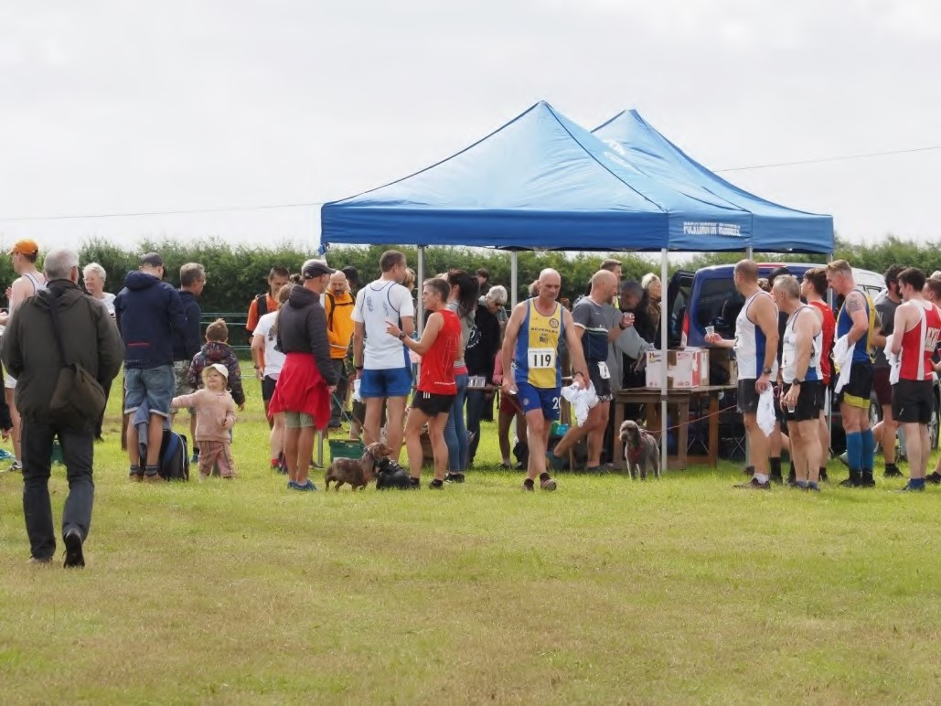
Bishop Wilton Show 2023
The unfavourable weather wasn’t enough to dampen the spirits of those attending the 125th Bishop Wilton Show. Some dramatic skies and enough rainfall to please the gardeners only mildly interrupted the
proceedings. Certainly not enough to stop the Starlings Aerobatics team with their exciting display.
With the revised show field layout, the focus as ever was on the Main Ring activities, and apart from the unscheduled rain interruptions was end to end action. The fabulous new run, the Bishop Wilton Beast, was sold out when the race started from here, with the new route very positively received thanks principally to Stuart Smith. This is certainly an event to build on.
The classic cars and vintage tractors were ably compered by Ed Hutchinson and were followed by the fabulous Owl Adventures. Later on in the Main Ring we saw the Percheron heavy horses, like the Show Jumping, back on the Schedule after a few years away. A wider range of horse classes certainly brought in more participants, and it was good to see nonstop activity on that side of the show field all day too.
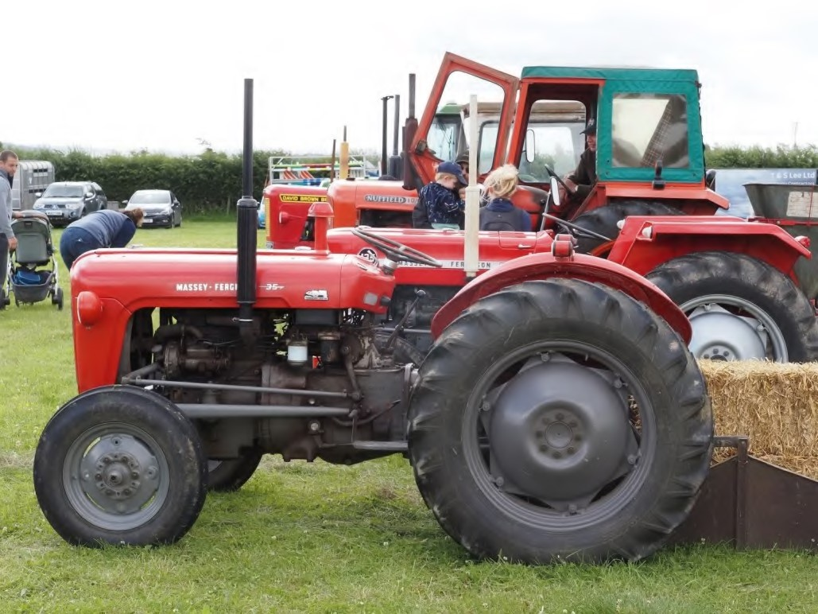
The sheep classes this year were really well supported, with judge Mick Walker kept very busy looking over some fine looking animals. It was good to see many entrants that hadn’t been before who will hopefully be back in future years.
As ever, the standard of entrants into the tent classes just gets better and better. Whether it be handicrafts, photographs, produce or home cooked food, it never fails to impress year on year. The Gait Inn from Millington put on a very well stocked bar. The real ale certainly travelled well, and it was the shelter of choice for many when the rains came. The same effect was felt in the craft tent which did a fabulous trade alongside the variety of food stalls that attended.
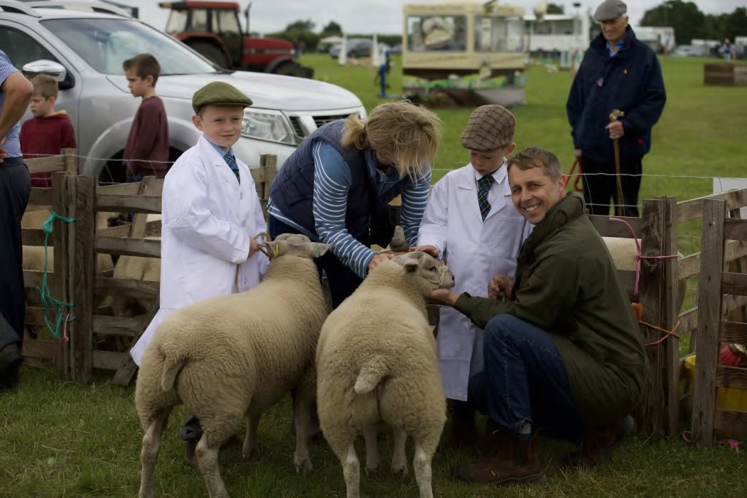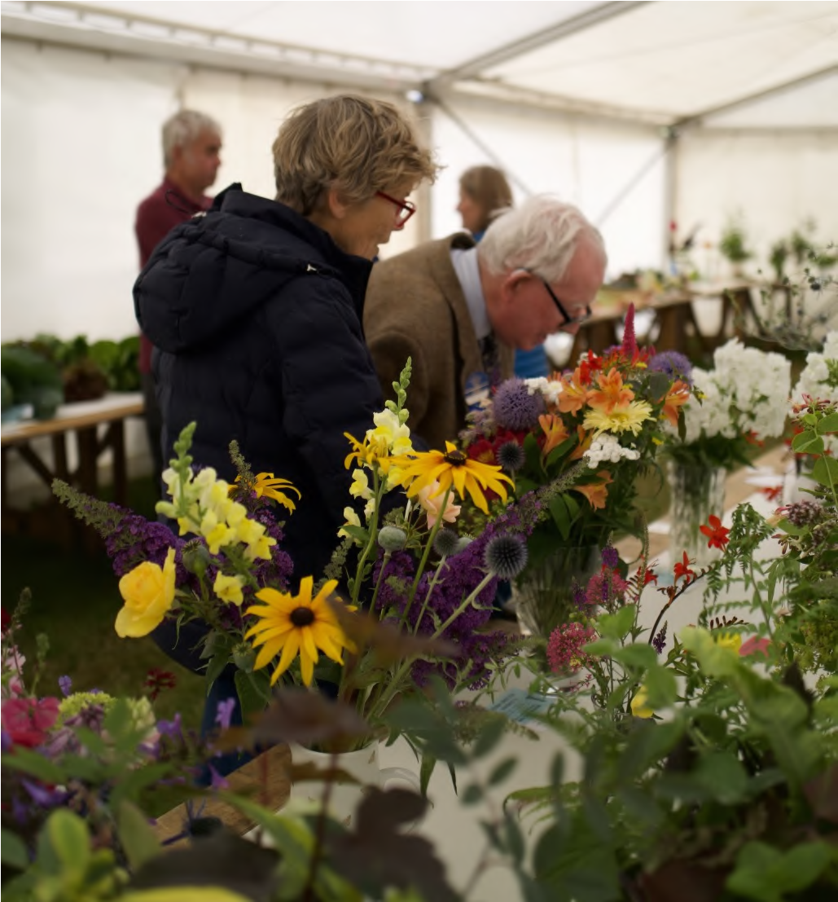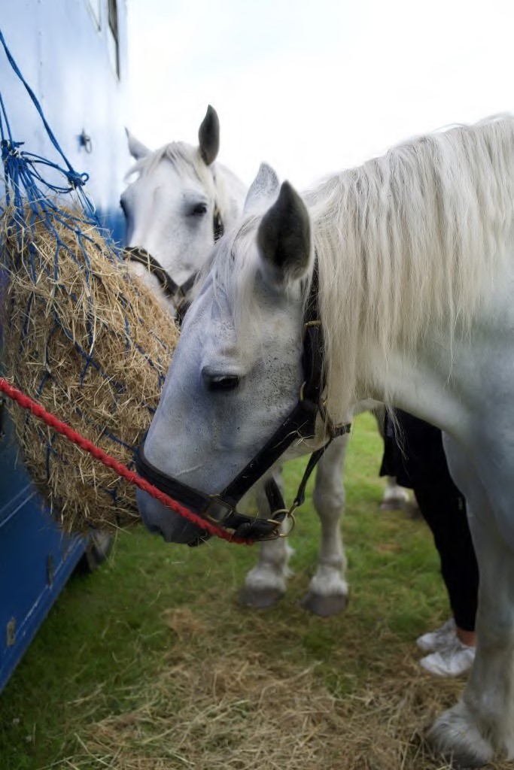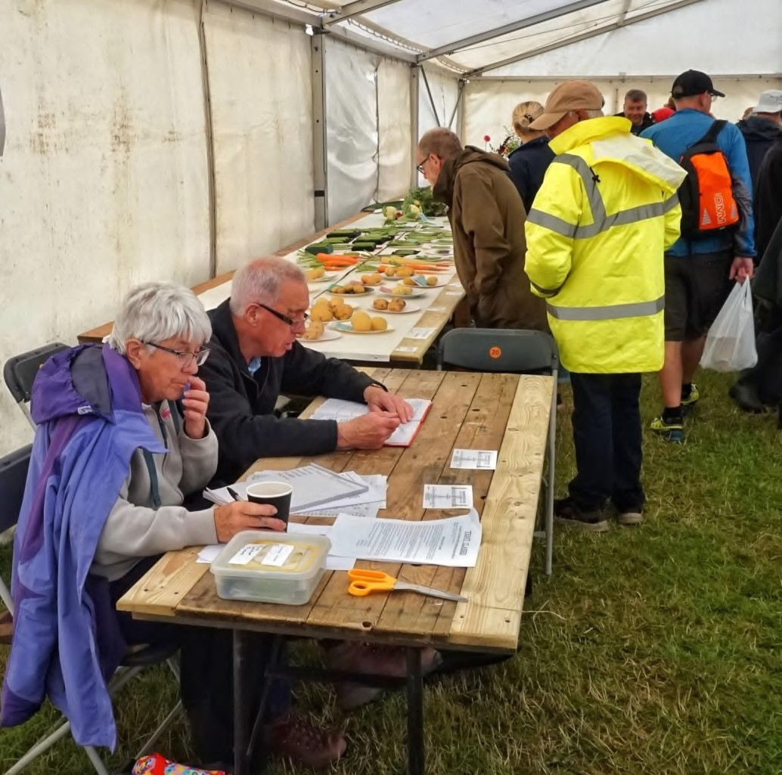
This year there was free entertainment for
children on the far side of the Main Ring.
Alongside the inflatable obstacle course and
the wonderful bubbleologist, the Purple Pig
Company from Pocklington kept the
youngsters occupied for hours.

There are many to thank for making it a very
memorable day: the Show Committee and all
the supporters who help to organise and build
the event, our sponsors, the Vice Presidents,
the President, the Stringer family and the
many that attended and participated in
everything that goes on at the show. Thank
you very much and we look forward to seeing
you on Saturday 20
th

July 2024.

Photos by Allan Wilkinson and Ian Jones

Beck and Bells
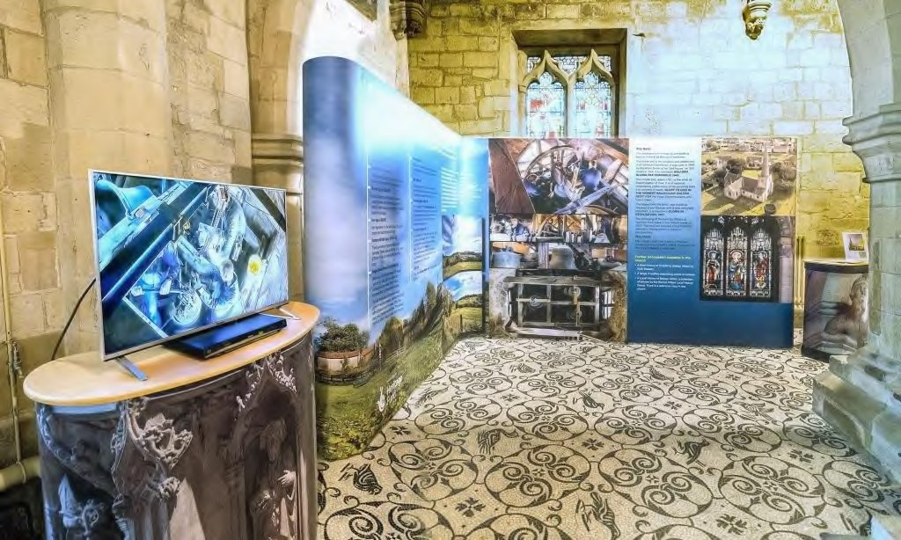
Our project is coming to an end and we’d like to thank you for your support over the last year. We can’t possibly name everyone who has taken part or volunteered but we are extremely grateful for all the help we’ve received. We must just mention the staff and children of Bishop Wilton School; the children have taken part enthusiastically, learning to ring handbells, exploring the beck and discovering what school was like for previous generations.

Bellringing Event
Don’t miss a special event starting at
10.30am on Saturday 12th August: Bob Sefton will be available in the church to demonstrate how the bells should be rung by hand. The bell ropes have been extended to the church floor so there’s no need to climb the tower stairs. Please come and have a go, and perhaps sign up as a volunteer ringer. Children are very welcome and will be able to ring the bells.

Beck and Bells Display
A new permanent display linked to the project can now be seen in St Edith’s Church. Look out for new films as they are added to the screen.

Rainfall
Rainfall for May and June 2023 in Bishop Wilton.
Rainfall for May 2023 34 mm (Average Rainfall May 2003-2023 55.1 mm)
Rainfall for June 2023 47mm (Average Rainfall June 2003-2023 64.4mm)
Rainfall for 2023 so far 301.5mm (Average Rainfall Jan-June 2003-2023 330.2mm)
Rainfall for the Meteorological Spring 2023
(March, April and May) 181mm (Average Spring rainfall 144mm)
May 2023 was somewhat drier than we could expect with Bishop Wilton receiving 21mm less rain than average. In the last 22 years I have recorded five drier Mays (2004, 2005, 2008, 2010 and 2020).
June 2023 was also somewhat drier than average with us receiving 17.4mm less rain Reminiscences - and a new regular column in the Parish Pump
One of the project aims was to encourage sharing of reminiscences. A few brave people have been recorded talking about past times in Bishop Wilton. A recording is a great gift to pass on to children and grandchildren, as well as providing valuable information about the history of the parish. A group of residents have also been into Bishop Wilton School to talk about their own time as pupils.
The next edition of the Parish Pump will launch a regular feature on memories of the Garrowby area. To be successful we need you! If you’d like to contribute an article of around 500 words please get in touch with Susan Frost on 01759 368445 or frost.susan@gmail.com.
than "expected". However, this is not unusual and I have recorded six drier Junes since 2003 (2006, 2010, 2015, 2018, 2021 and 2022).
One unusual feature of the data for May and June 2023, however, was the 29 days from the 20th May to 17th June where I did not record any rain whatsoever - not even a "trace" (less than .1mm).
The rainfall totals for 2023 so far show that we have had a drier than average 2023 with just over 1" less precipitation than the 13.5" that is the 20 year average for Bishop Wilton.
Due to a wet March, the rainfall totals for the meteorological spring (March, April and May) are actually higher than average- 181mm compared to an average of 144mm.

Ian Jones ialima2@gmail.com
Bishop Wilton Hall
July 2023 – No. 1 Staying in Touch
Welcome to the inaugural newsletter of Bishop Wilton Hall. Our aim is to issue a newsletter at least twice a year which will be published on our website, sent to the regular hirers of the Hall, and published in the Parish Pump.
As this is our first issue, we would like to introduce ourselves and highlight the work that is ongoing to provide what we believe, is a truly wonderful facility in our village.
First of all, we would like to explain the reason for the recent scaffolding that you may have seen at the Hall:

Installation of Solar Panels
Thanks to part of the very generous gift to the village by the late James Goodhart we have
been able to install solar panels along the Worsendale Road side of the roof as well as battery storage which will reduce our electricity bills and hopefully provide an income to the Hall via the national grid. The panels are now fully operational, and we have already seen a significant reduction in reliance on usage from the national grid. In addition to the Solar panels, digital thermostats have been installed throughout the Hall so that each area can be individually heated to avoid energy waste.

Introduction
Our “year” normally begins on the 1st of March which marks the start of our financial year. One of the first events in the calendar is the AGM, which this year took place on the 19th April 2023. The AGM is advertised in advance in the parish pump and on the village notice board. It is at the AGM that the Trustees stand down and, are offered for re-election or new Trustees appointed. The current Trustees are, Peter Goodrick (chair) Ian Robson (treasurer) Viv Guy (bookings) Sara Dace-Hughes, Kevin Dann, and Michele Lucas.

Post Covid
As a result of Covid, we lost a few significant users who regularly hired the hall. Whilst we have seen new user groups using the hall our bookings have not recovered to pre covid levels. In fact, when we look at the bookings between January and May 2023, they are 4% below what we saw immediately after lockdown. We do not know if this a long-term change and/or people tightening their belts as inflation rises.
What are the Trustees doing?
Their focus is the maintenance and running of the facilities to the benefit of the community. Currently we have been maintaining the sports fields. Rearranging the storage facilities to make it safer and easier for users to access the equipment that they need and reduce the risk of damage. Ongoing daily repairs to the building fabric and landscaping etc…
Four of the memorial benches were recently renovated – those in memory of:
John W Earnshaw 1932-2010 ‘The Jolly Farmer’
Colin Robinson 1940-2017 ‘Happy Days’ Electrician, Village Stalwart and Trustee of the hall
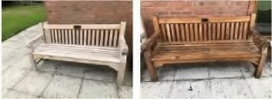
Lawrence West 1927-2010
Walter 1919-
2009 and
Winifred
Chapman 1920-2012

Financial Matters
The two main sources of funds available to the hall to help maintain its upkeep are the charges that the users pay, and third-party funding (grants, donations etc). We strive to cover the hall running costs and sinking fund contribution (money set aside for the future replacement of high-cost items) from user charges. Third party funding is normally sought for big projects (e.g., the refurbishment of the tennis courts and the creation of a multi-sport facility).
The hall costs over £15,000 per year to run which on average is £1,250 each month without a contribution to the sinking fund.
Like everyone else we are seeing our costs rise.
Since the hall was opened 2010 the hire charges remained the same until 2021. Since 2010, inflation has risen by 64.05% and by 22.54% since 2021. In addition to the recent installation of solar panels and battery storage to reduce our energy costs and of digital thermometers to more closely regulate our energy consumption we also aim to
- Closely monitor usage, income, expenses, and charges.
- Work to promote our facilities to potential users from the wider community.
It is hoped that these changes will help to minimise any future cost increases that may have to be levied.

Our Website
We are in the process of updating our website to include all the groups who use the Hall – please have a look via the tab ‘Village Links’ @ bishopwiltonhall.co.uk.
We are also in the process of updating our ‘What’s On’ facility to make it easier for you to access details of when the various groups are running and any other events coming up.

Hall Users
In addition to the regular groups, the Hall is also available for hire for weddings, children’s birthday parties, race nights, balls, business meetings, fashion shows, music nights, DofE camping, caravan clubs and much more. So please contact us via bishopwiltonhall@gmail.com to find out how we can help you book your event.

Getting Involved
If you would like to become involved with the running of the Hall as a volunteer, we would love to hear from you! As you can see from reading this newsletter the tasks involved to ensure the continued smooth running of the Hall are varied and numerous. And, as we know, many hands make light work! We had a fantastic turnout on the Sunday following the King’s Coronation helping to clean the Hall – if you participated and were wondering how you could become more involved, please get in touch.
In addition to this we are looking for a volunteer with a little time available to review potential external funding opportunities to see if there is something which the hall could take advantage of.

And last but definitely not least...Huge congratulations to the Firebirds, the Ladies Netball Team, who won their division in the York and District League Sept –April in 2022 and gained promotion.
They have also recently won their division in the Tuesday (year-round) Yornetball League, gaining promotion to Division 1.
They also play in the Bibz n Balz League yearround entering 2 teams each season with players regularly awarded player of the season by opposing teams and have also won their FairPlay award.
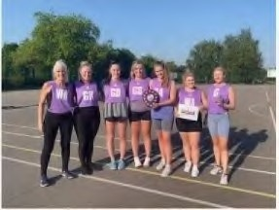

‘We train most weeks on Wednesdays 7pm at
Bishop Wilton Courts. Fun, fitness, drills and socialising.
We are a friendly team of mixed abilities, always welcome new members.
Contact details via our Facebook site or
Website: bishopwiltonhall.co.uk / Email: bishopwiltonhall@gmail.com
07733161540’ https://www.facebook.com/BWFirebirds

Fleece Inn Golf Club
This was our second outing of the summer to one of our regular venues, Cottingham G.C. The conditions were good - overcast as we tee’d off but the sun breaking through during the round. Cottingham G.C. has developed tremendously over the years with its golf course and leisure facilities - gymnasium, squash courts, swimming pool, restaurant and bar etc. The big car park was almost full on the day which is remarkable for mid week! There was a good turnout of competitors, 19 in all, so went out in four 4 balls and one 3 ball. The course was well presented -fairways nicely cut and the greens tidy apart from a couple being a little under standard. There are a number of ditches crossing the fairways but were dry because of little or no rain. A number of ponds are strategically placed and the writer still hasn’t learned that golf balls will not float!! The round seemed to keep up a good pace, signifying not a lot of lost ball disasters!? Following the golf we sat on the bar balcony and enjoyed liquid refreshment. Our host for the day, Gebs Brigham, did a fine job of greeting the players on arrival, sorting out the draw, and ultimately adjudicating the scores. Our recently elected new Parish Councillor, John Miles, had a good day - second in the main competition and two nearest the pins on the par threes! Well played John. Now for the all important scores:
1st Allan Aikman 37pts
2nd John Miles 37 pts (on countback)
3rd Col Pollock 35 pts
4th Paul Lindley Curtis 34pts Spot Prizes: Nearest the pin with tee shot on par three holes:
4th hole - a tie between Col Pollock and Dave Etherington - shared prize.
8th hole Charles Fenton
14th hole John Miles
16th hole John Miles
Nearest 17th par 4 hole in 2 shots Luke Fenton actually hit his second shot directly down the hole!! an Eagle!! After the golf we sat down to a super plate of Fish & Chips or Curry- both delicious.
Following the meal Gebs followed Colin Robinson’s tradition in asking one of our young waitresses to present the prizes. The inevitable kiss was suggested - and clinches no longer than two minutes agreed!! Luckily a peck on the cheek seemed to suffice!! All in all a great day out.
On 5th July we visited Hainsworth Park which is one of our regular courses to play and one of our favourites if only for the fabulous steak meals following the golf. We had a great turnout 20 players, reflecting the popularity of the course. Our volunteer host for the day was Martin Butcher who prepared the score cards and adjudicated the scores when we completed the round. Thanks Martin for your help!
The day was quite cloudy with a stiff breeze, little or no sun but it didn’t rain. The course was in reasonable condition - being a Parkland course with many established trees there was evidence of the recent storms with lots of small branches and leaves scattered around. The fairways did look a little bare and dry, and the many streams crossing the fairways were empty and the ponds almost dry - the recent dry spell taking its toll. The greens were ok but we have encountered them in better condition, but for what we pay and a steak meal it represents great value. Now for the all important results:
1st John Green - 39 points
2nd John Miles - 38 points 3rd Matt Jones - 36 points
4th Gebs Brigham - 36 points (on countback) Spot prizes: Nearest the pins on par 3 holes with tee shot 6th hole – No winner
16th hole - John Green
18th hole Martin Butcher
Nearest par 4 15th hole pin in 2 shots –
John Miles
Nearest 17th par 5 hole pin in 3 shots – Gerald
Fenton
Following the golf we enjoyed the traditional steak meal and have to say you would have to travel a long way and pay a lot more for a better steak!!
Martin then presented the prizes to the deserved winners which rounded off a very enjoyable day out.
Why not join us on our next outings Wed 6th September Hessle Golf Club, and our final competition Wed 4th October Cave Castle Golf Club. More info.fleecegolf.co.uk
See you on the tee! Bob Sefton

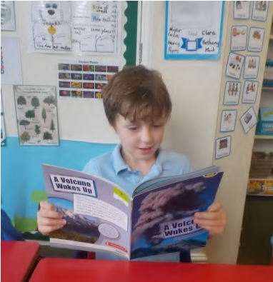
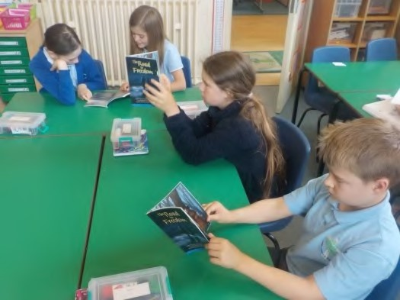
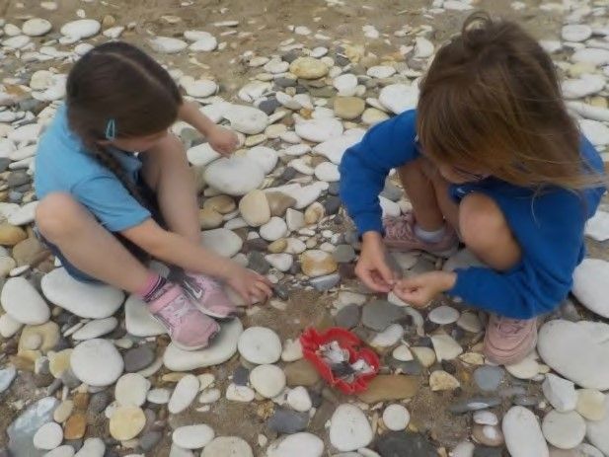
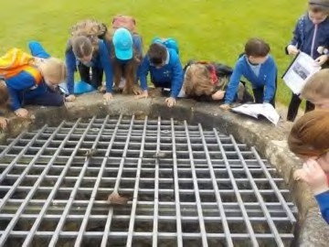
Bishop Wilton CE Primary School
We would like to say a huge thank you to the Bishop Wilton Community Benefit Trust for the allocation of a generous
grant, enabling us to extend and develop our guided reading books with exciting titles, closely matched to our phonics programme. The children were very excited to open the boxes that arrived in school and pick out titles they were keen to start reading. Those we have shared with our guided reading groups have already proved a hit and have fired the enthusiasm of all our readers.

The Summer term has provided exciting opportunities for both classes. This year KS1 and Reception children took the train to Bridlington as part of their history and geography topic work. They explored the harbour, ate ice cream, played on the beach and rode along the promenade on the land train. The weather stayed fine and everyone had an excellent experience.

KS2 visited Scarborough Castle as part of their topic work, exploring different aspects from their learning in class. They explored features of the coastline, erosion and the history of the castle.

Our pop in and play sessions will continue in the autumn term and everyone with a baby or toddler is welcome to join us on Wednesday afternoons during term time, for as much of the session as they would like. There is time to enjoy a chat and a cuppa while children can explore and play in our exciting indoor and outdoor areas. Just come along and join us in our happy and friendly setting, between 1.15 and 2.45pm.

Please do follow Bishop Wilton
School on Facebook or Twitter
@PrimaryWilton to see lots more pictures of all our exciting activities.
Mrs Jean Louden, Senior Teacher
Church News From the Rectory, Worsendale Road, Bishop Wilton 01759
369974, 07888 668663 garrowbyvicar@gmail.com www.garrowbychurches.com

From Mike
If you have not already visited, a trip I can recommend over the summer is to Rievaulx Abbey. It is an eleventh century Cistercian ruin which you can walk to from Helmsley. The setting in the valley is breath taking and so very peaceful. Afternoon tea in Helmsley is also highly recommended! One of the Abbots is especially remembered for his writing on friendship. Aelred identified what he called worldly friendships which are based on mutual gain or perhaps a shared interest. These are people we might work with or perhaps friends at a sports or social club. There is nothing wrong with such friendships, but Aelred goes on to talk about the importance of spiritual friendship. In his book of the same name he talks about the importance of people with whom we can rest and to whom we can pour out our soul, someone who can “shed tears with you in your worries, be happy with you when things go well and search out with you the answers to your problems”. Although writing in the twelfth century Aelred’s words continue to be relevant. A recent survey by the Movember foundation found that many men do not have a person with who they can discuss a serious topic and that one in four are only in contact with a friend once a month. Research shows that women are generally better at sustaining friendships and being vulnerable and sharing but the importance of friendship is key to mental and spiritual health for everyone of whatever age. In the gospels Jesus calls his disciples “friends” and other great leaders have also had people around them for support and companionship, Mohammed had his companions, the Buddha had the Sangha.
It is easy to let friendships lapse because of being too busy with other things. They take time to nurture and maintain, but it is time and energy well spent. It has often seemed to me that in popular culture, romance is celebrated, just listen to many pop songs or look at the plot lines in the soaps, but friendship isn’t often valued even though it is so important for our wellbeing. Having lots of virtual friends isn’t a replacement for the time we spend face to face with someone over a coffee and with whom we can truly “be ourselves”. So if you can during the holiday season when things are a bit less pressured, take a bit of time to ask yourself about how you are doing as a friend and perhaps reach out to someone whose friendship you value yet have perhaps neglected because of work or family commitments. Maybe even go on a road trip to Rievaulx with them….
(if you are interested I can recommend The
Lonely Century by Noreen Hertz Sceptre 2021 and there is an All in the Mind Podcast on Male Friendship)

Benefice Service
30th July Fifth Sunday Benefice Service 10.30am St Mary Full Sutton. St Mary’s has had a tough time with not only the Covid closure but also the ceiling collapse so do please support them and enjoy the joint celebration for all our villages. Please note there will be no 4.00 service at Full Sutton on the 17th September as the Harvest Festival will be at 4.00pm on the following

Sunday, 24th (see below) Family Services in August
Both the service at Skirpenbeck on at 10.00 6th August and the one at Bishop Wilton on the 27th will go ahead as usual even though people may be away. We will remember everyone on holiday.

Craft Afternoon
On Sunday 6th August there will be the usual Service for All at 10.00 at St Mary, Skirpenbeck and in the afternoon from 2 – 4 there will be a craft afternoon including rock painting. There will also be refreshments and donations will go to St Mary’s. Everyone will be very welcome.

Garrowby Churches Meditation Group in St Edith’s Bishop Wilton 7.00pm
The next meetings will be on Thursdays 10th August and 21st September. They last for about 40 minutes with an introduction, time of silence and closing reflection. The chance to be still can be helpful and everyone is very welcome.

Garrowby Benefice Harvest Services
I know this is early but with the Pump being bi monthly I wanted you to have all the dates for your diary: Sunday 24th September
10.15 Bishop Wilton
16.00 Full Sutton – with the Garrowby Singers
Sunday 1st October
10.00 Skirpenbeck
11.15 Kirby Underdale
Sunday 8th October 09.15 Bugthorpe
All will be followed by refreshments. Look out for posters and details in the weekly e mail.

From the Registers Baptism
9th July Emelia Marie Smith and Zara Grace Smith at St Edith’s, Bishop Wilton
“We welcome you into the Lord’s family”

Funeral
20th July Mark Stringer St Edith’s, Bishop Wilton
“May he rest in peace and rise in glory”
The Garrowby Singers Summer Concert
The Garrowby Singers summer concert was held on Saturday 8th July at Bishop Wilton village hall. After many months of Wednesday evening rehearsals, the choir were delighted to present their latest pieces to a very appreciative audience. It was wonderful to see so many people in attendance - thank you to everybody who came to show their support. As always, the choir took the opportunity to raise funds for a local charity resulting in £500 going to Hearing Dogs for deaf people. Thank you again to everyone who came along - your support is hugely appreciated. We look forward to seeing you all at our Christmas concert on 16th December at St. Edith’s Bishop Wilton.

St. Mary’s Skirpenbeck
We continue to hold a service for all on the first Sunday of the month at 10am. There are always refreshments after the service. Future events to be held in St. Mary’s
Sunday 6th August 2-4pm - Rock painting/ craft session for children. Please wear appropriate clothing. There will be refreshments available. This is a free event but any donations for refreshments will be hugely appreciated!
Saturday 9th September 2-4pm Cake and a Cuppa at church. All welcome.
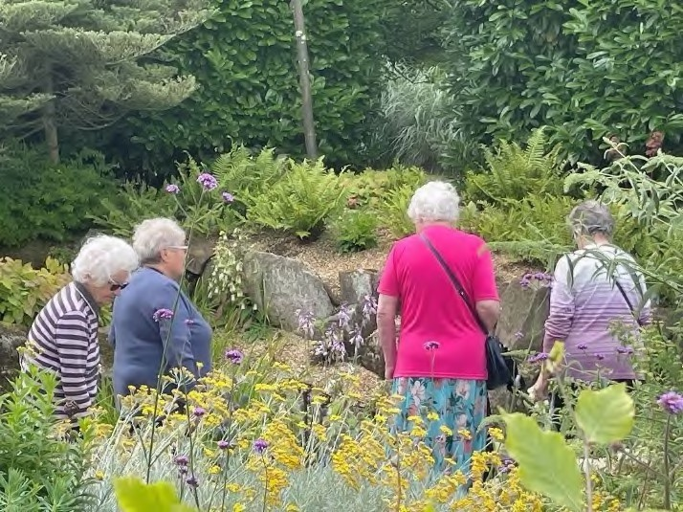
Penny Beard
Friendship Group

We have been meeting since October 2022
for a coffee (or tea), a cake and a chat.
Last week we decided to decamp to Burnby
Hall Gardens for a stroll round the lake.
This was followed by a lovely lunch
provided by the Lilly Pad Café.
Fortunately, the rain held off until it was
time to leave.

If you would like to come along to the
group, we meet in the club room of the
village hall on a Tuesday morning 11
-
1
. We
would love to see you there!

Michele Lucas

Schedule of  Services | St. Edith’s  Bishop Wilton | St. Andrew’s  Bugthorpe
30th July
5th Sunday Benefice
Service
6th August  9th after Trinity | 08.00 Holy Communion
13th August  10th after Trinity | 11.15 Eucharist | 09.15 Eucharist
20th August
11th after Trinity
27th August  12th after Trinity | 10.15 Family Service/  Service for All | 09.15 Eucharist
3rd September 13th after Trinity | 08.00 Holy Communion
10th September 14th after Trinity | 11.15 Eucharist | 9.15 Eucharist
17th September 15th after Trinity
24th September 16th after Trinity | 10.15 Harvest Festival  Family Service | 9.15 Eucharist
1st October  17th after Trinity | 08.00 Holy Communion
Church Wardens: | Susan Frost 368445  Jan Danby 369934 | Verity Jarry 368775

St. Mary’s  Skirpenbeck | St. Mary’s  Full Sutton | All Saints  Kirby Underdale
 | 10.30 Benefice Holy Communion
10.00 Service for All |  | 11.15 Holy Communion
 | 4.00pm Eucharist | 11.15 Eucharist
10.00 Service for All |  | 11.15 Eucharist
 | NO 4.00pm Eucharist 11.15 Eucharist
 | 4.00 Harvest Festival with the Garrowby Singers
10.00 Harvest Festival  Service for all | 11.15 Harvest Festival
Penny Beard  07771 623639 | Richard Smithson 07951 William Foster 368713  232626 and Adam Finlay and Pam Megginson  07793651403 372205

Bishop Wilton WI
Bishop Wilton WI welcomes women of all ages. We are a friendly group, why not come to a meeting as a guest and see what we’re about and consider joining us!
June’s meeting was a lovely social gathering hosted by WI member Paula. Copious amounts of cake, strawberries and Pimms were enjoyed and the sun was kind enough to last long enough to explore the lovely garden.
July’s meeting was a fascinating talk about holistic health. Charlotte Gray, a homeopath, talked about the importance of treating the whole person, not just symptoms, and the use of homeopathic remedies. Nicola Sainty, a nutritional therapist, explained the role of a good diet in boosting the immune system to promote good health. Both are members of the Blossom Health Hub based in the East Riding which brings together different natural health practitioners who see their practices as working alongside conventional medicine.
The meeting on Wednesday August 9th is a trip to see the Stamford Bridge Tapestry. On Monday September 4th there will be an informative talk by Wolds Hedgehog Rescue. This is an open meeting for all and the cost is £4 on the door to include refreshments. Please come along and find out how we can help these endangered animals. Meet 7.15pm at the Village Hall. The next Coffee, Cakes and Books will be on 26th August from 10am-12pm.
Ruth Mardall
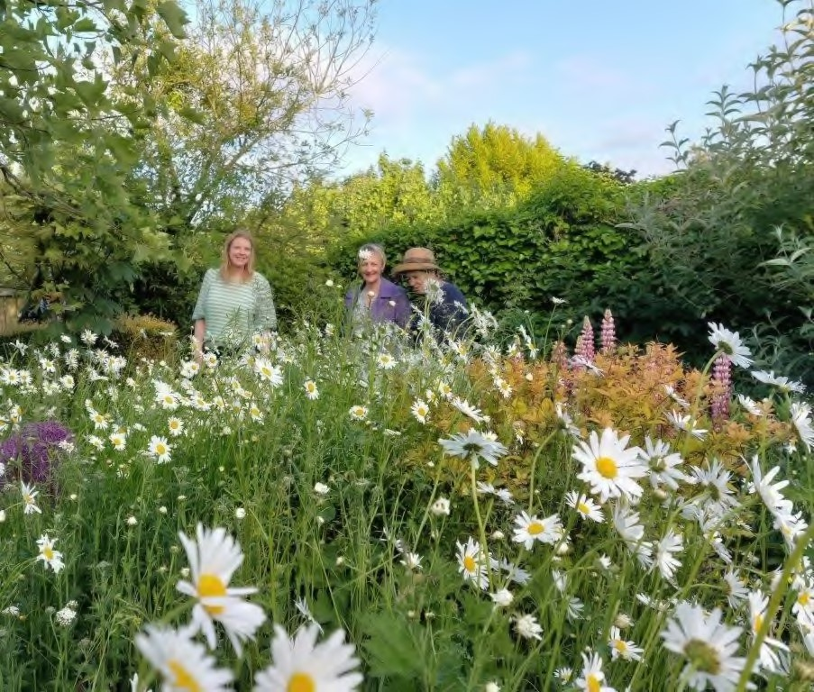
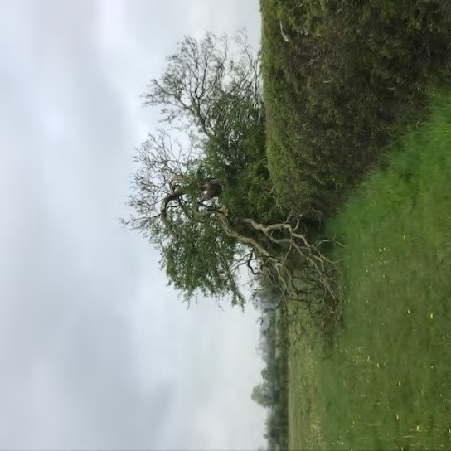

Coronation morning
Time has beaten the old ash, in death throes, splayed, its trauma blocks the path.

A dragon slain, its limbs crowned with spring green coronets anointed by the dewy morn, the final burst before its life force fails and they shrivel and retreat like last year’s leaves.

So many crownings passed since you took hold to rule the hedge, a chosen one from thousands born to fly but never thrive you were that key, until the hour your body split and died.

A pilgrimage I made and found you, razed, battered by a storm of rage. A scene of demolition, I grieve the pain of wholeness broken. Now I must choose another route to move around the old, a rite of passage journeyed to find a newer world.

Ruth Mardall

BW Table Tennis Club

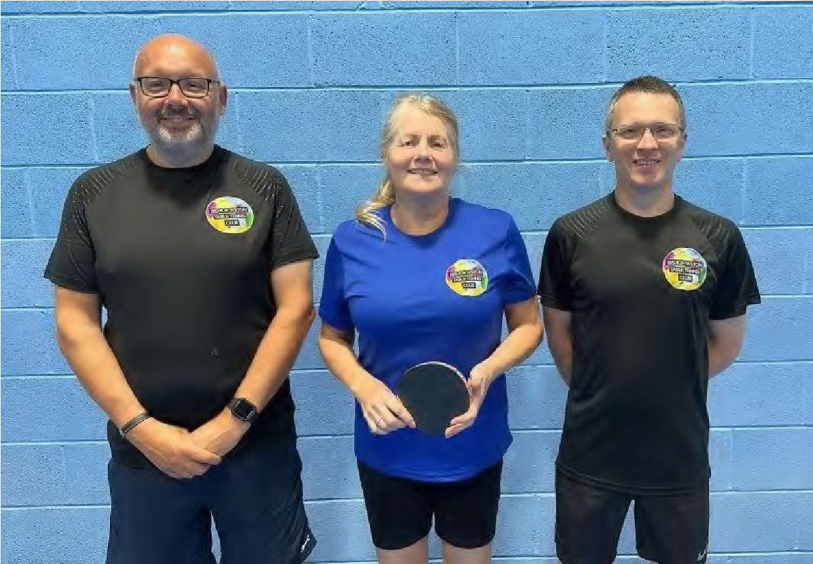
Breaking news! We're joining the Rydale Table Tennis League where we'll be competing against other clubs, mainly from the Pickering and Malton areas. In preparation, we've played three friendlies, v Rillington, Westow and Shiyi Ling table tennis clubs, providing members with valuable experience. Our squad of seven players have enjoyed the games and played well, winning one, drawing one and losing one. Two further friendlies are planned. There's lots of information about our journey, from a newly formed small club to a confident league team on our website. People are busy in the summer. Many clubs attendances, not just table tennis clubs are affected. On Wednesday 28th June we sent a team to play Rillington Table Tennis Club, two of our members were away on holiday, another injured; but still 10 members turned up at the village hall to play. We have a keen, loyal and competitive membership of varying abilities and ages.
Every week members play in internal competitions but if preferred, play amongst themselves for fun. We're a members club first and foremost. Members choose how they'd like to play table tennis and who they wish to play with. Our committee is there to support. With Anthony, an official Table Tennis England (TTE) coach residing in Bishop Wilton, we're able to offer free coaching to members new to the game or experienced players wishing to improve. We have a membership of 21, consisting of 18 adults and three younger members. Most of our members have also joined TTE as Club or Compete members, enjoying the additional benefits of belonging to our governing body. We'd like to see more young people attending and we're working with TTE's initiatives to try and make it happen. Thomas is a Cadet Member of TTE and is making the most of his membership of BW TT Club by improving his game every week, whilst working towards the Duke of Edinburgh's Award. As he works towards achieving this prestigious award, table tennis is his chosen sport. Every week, to improve his game he works with our club coach. We're enjoying seeing Thomas enjoying the game and improving, if he chooses he can play for BW TT Club in the league next year.

Carl, Jo & James v Shiyi Ling
Thomas and other young people can achieve whatever they wish in table tennis, through playing in Bishop Wilton. We're delighted to offer Thomas and others this opportunity. Although only at an early stage, we'd like to set up Table Tennis England's Tr Kidz programme in Bishop Wilton. Look out for more on this in the future.
There's no minimum age to play in the Rydale Table Tennis League. Anyone aged between 12 and 18 who'd be interested in joining us, contact any club member or come along on a Wednesday evening. Those aged 12 to 18 should be accompanied by a responsible adult. One of the concerns of TTE and table tennis clubs throughout England is the shortage of young people taking up the game. At Bishop Wilton we'd like to play our part in introducing more young people to table tennis. That doesn't exclude us older ones! If your not as young as you used to be, but fancy coming along, please do, we'd love to see you.
We're currently saving through a fund raising scheme to buy new table tennis tables, and we're working on other ideas, hoping to achieve this. If you wish, you can find out more through our website or contact any member of the committee. As we'll shortly be competing in the local league we'd like to find a local business to sponsor us. If you’re interested, please get in touch. Whatever your experience or skill level as a table tennis player, you're welcome to join us.
Wednesday's 7pm till 8.30pm.
Clever Solutions for Awkward Living Room Layouts
The Committee e: enquiries@bwtt.uk bishopwilton.ttclubs.co.uk When it comes to living room layouts, some spaces can be challenging to work with. It can feel frustrating when awkward nooks and corners can cause havoc when planning a space. We might start to feel frustrated that our lounge doesn’t look like they do in Instagram or Pinterest!
However, with a little creativity and thinking
For example, you might create a seating area with a sofa and armchairs on a large rug, a reading nook with a cosy armchair and bookshelf, or a workspace with a desk, chair and practical lighting. By defining these separate zones, you can make your living room feel more organised, spacious, and functional - no matter the size or shape.

Use the Walls
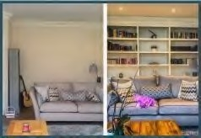
One of the best ways to deal with an awkward living room layout is to use the walls to your advantage. This means utilising vertical space with floating shelves, wallmounted storage units, and hanging plants. You can also create a gallery wall with a mix of artwork, mirrors, and decorative objects to draw attention away from the awkward areas of the room.
outside the box, at Grandad
’
s Shed we
believe you can transform an awkward living
room into a cosy and functional space. Here
are some ideas for making the most out of a
challenging living room layout.

Create Zones

This can be particularly useful for large or
open
-
plan spaces, where you want to make
the most of every inch whilst still creating a
warm and homely space.

So how do you achieve this? It can be as
simple as clever use of furniture placement,
area rugs, wall paint or lighting.

ceilings and a more spacious feel. It draws
the eye up and add a perfect mix of drama
and cosiness to the room.

Play with Angles

Another favourite trick during our interior design services is to install floor-to-ceiling curtains to create the illusion of higher
If you’re still struggling with an awkward living room layout, playing with angles can be a clever solution to create a more functional space. Try angling your furniture to create a more dynamic flow and open up the room.
Written by Vicki Kress, Interior Stylist for Grandads Shed.

If you’d like a guiding hand with interior style, call Vicki Kress Interiors on 01759 306777.
For example, instead of placing your sofa directly against the wall, you might try positioning it at a diagonal angle for a more interesting and visually appealing layout

Bishop Wilton Parish Council
Minutes to the Annual Meeting of Bishop Wilton Parish Council, held on Thursday 18th May 2023 at 6.30pm in Bishop Wilton Village Hall.
Present: Ingrid Haywood; Iain Rickatson; Paul
Rigby; Ashlea North; Jo Denton; John Miles; Cllr R Sumpner and Sandra Morrison (Parish Clerk)
286. Apologies were received from S Berry, and
P Warry. P Rigby arrived during the meeting at 6.45pm and I Rickatson and R Sumpner at 6.55pm. 287. In the absence of the outgoing chair, it was resolved that I Haywood chair the meeting. 288. Nominations for P Warry to take the Chair
(from the next meeting) were proposed by
I Haywood and seconded by J Miles. Resolved 289. P Warry had previously indicated that he would accept the role of chair if nominated, and he would sign his acceptance of office in accordance with regulations as soon as he returned. 290. Members declaration of acceptance of office were received and signed by the clerk. 291. Cllr North nominated Cllr Haywood for the position of vice chair, seconded by Cllr Denton.
Resolved
6.45pm Cllr Rigby joined the meeting with apologies.
- Cllr Rigby signed his Declaration of acceptance of office and delivered his Chair’s report for 2022/2023, which is attached as an appendix to these minutes.
- Approval of delegation of committees and appointment of officers –
Personnel – Cllr Haywood, Berry and North – chair of the committee to be elected at the first meeting. Playground - vacant
Flyers and advertising – Cllrs Haywood and Miles
Gritting - Cllr Rigby and others as required
Planning – whole council
6.55pm I Rickatson and R Sumpner joined the meeting and duly signed their Declaration of Acceptance of Office.
Cllr Sumpner advised that he would be recording the meeting and may use the recording for sharing with third parties and not keep the information for his personal use.
294. Councillors areas of responsibility and representation were agreed School – Cllr North
Village Hall – Cllr North
Planning – Full Council
Highways – none
Notice Boards – Cllr Denton (keys currently held by Cllr Sumpner and Cllr Rigby)
Crime Liaison – Cllr Rigby
Footpaths and Bridleways – Cllr Rickatson 295. Representatives of this Council at ERNLLCA district committee meetings were agreed as Cllrs Sumpner and Haywood. 296. The inventory of Land and Assets was reviewed and it was proposed by Cllr Haywood and seconded by Cllr Rigby that the value of the bus shelter be amended to a more realistic figure of £3,000. Resolved. It was proposed by Cllr Rickatson and seconded by Cllr Rigby that all other values be accepted as stated. Resolved 297. The insurance cover was reviewed and approved.
298. The following governing documents were reviewed.
Code of Conduct – as presented no change
Publication Scheme – as presented no change Complaints Procedure and Guidance- as presented no change
Finance Regulations – to be amended at
clauses 3 and 4
Meeting closed 7.12pm

Minutes to the Meeting of Bishop Wilton
Parish Council, held on Thursday 18th May 2023 directly after the Annual Meeting, at Bishop Wilton Village Hall.
Present: Cllrs I Haywood (Vice Chair); P Rigby,
I Rickatson; A North; R Sumpner; J Miles; J
Denton and Sandra Morrison (Parish Clerk)
5 members of the public
The meeting opened at 7.13pm 299. Cllr Haywood chaired the meeting, and welcomed members and guests. 300. Apologies of absence were received from
P Warry and S Berry
301.Code of Conduct: To receive Declaration of Interests from members on any items on the agenda: Pecuniary - none; non-pecuniary - none; granting of dispensations - none. 302.Open Forum: To resolve that the meeting be temporarily suspended to allow for a period of public participation. A member of the public spoke about the planning application (agenda item 13), as the owner of the cottage she advised the council that she was unaware of the second clause and is happy to answer questions. Another member of the public voiced her support for the couple who have been very supportive of other members of the public. The chair requested that agenda item 13 be moved to be heard next. Resolved
303. Planning Application 23/01297/VAR Proposal: Variation of Condition 8 (Occupancy restrictions) and Condition 9 (occupancy restrictions) of planning permission 03/03974/ PLF – Erection of four holiday cottages to allow for holiday occupancy restrictions to relate to lodges 1,3 and 4 only
Location: Land at Mill Hills Main Street Bishop
Wilton
Applicant: Julie Roberts
Application Type: Variation of Conditions (s) It was proposed by Cllr Rickatson and seconded by Cllr Rigby that the change of use should be supported. That the variation of condition 8 and 9 should be granted for the term of the occupancy of the current residents in their capacity as working at the facility, and for no other. All agreed - Resolved 304. A letter was read out from the PCC requesting support and the matter was deferred until the next meeting
305.Ward Councillors Report and outstanding issues
1. Update on Humber Forest tree planting scheme – awaiting feed back 2. Clearance of beck behind Vale Crescent –
Clerk to instruct Cllr Hammond to speak to
Halifax Estates
- Pedestrian safety on the stretch of road between Vicarage Lane and Main Street - deferred
- Update on erosion of grass verge along
Givendale Road - deferred
- Update of blocked drains in Gowthorpe - deferred
- Minutes: It was proposed by Cllr Rigby and seconded by Cllr Haywood to adopt minutes of the meeting held on the 24th April 2023, subject to a change to ref 275 open letters to correspondence. Resolved
- Matters Arising: update on outstanding items from previous meeting.
a) Response re repair to village roundabout – Cllr Sumpner to visit contractor to obtain a response b) Update on Kings Coronation celebrations – lovely weekend, fully supported by volunteers. Table tennis very successful bringing new people in. Good community feel, and successful events.
- Update on chairman’s award nominations – our nomination for the village shop, won. Cllr Haywood and volunteers attended the award ceremony, which was a fabulous evening. It was proposed by Cllr Sumpner and seconded by Cllr North that a letter of congratulations be sent to the community shop. Resolved
- The draft Heads and Terms of letting agreement between the Council and the village hall in respect of the land for the proposed outdoor gym was discussed and it was proposed by Cllr Haywood and seconded by Cllr Rigby that this be agreed by the council. Resolved. A copy of the heads and terms has been issued to the village hall committee in order to proceed to the next stage.
- Compilation of a list of actions to be addressed by the village walk about team – Cllr Sumpner offered to walk around the village and compile a list of issues for the clerk to submit.
- Response to community payback team request on refurbishment of notice boards – Cllr Rigby will provide stain, sandpaper etc and be the main point of contact in order to proceed with the work.
308.To consider the formulation of a policy to deal with the issues of damage to the village green – parts of the village green are being destroyed by vehicles and one area in particular is now dangerous. Cllr Rickatson to speak to the resident concerned, and the issue to be raised with the village walkabout team.
309. Finance:
- It was proposed by Cllr North and seconded by Cllr Rigby to approve accounts and bank reconciliation to date. Resolved
- It was proposed by Cllr North and seconded by Cllr Rigby to approve payment as per schedule 2 clerk’s remuneration. Resolved
- It was proposed by Cllr Rickatson and seconded by Cllr North to approve payment of internal auditor’s invoice 23/707 for £110. Resolved
- The internal auditors report was circulated and acknowledged.
- The AGAR assertion statement was reviewed and complete and it was proposed by Cllr Haywood and seconded by Cllr North that this be approved. Resolved.
- It was proposed by Cllr Haywood and seconded by Cllr North that the AGAR financial statement be approved. Resolved
310. Community Issues for consideration 1.It was agreed that the Village Grass cutting schedule for June be moved forward slightly to end of May to accommodate contractors holiday period.
2.The extending of the paving at the bus stop has been scheduled. The concerns raised by a resident with mobility issues have been addressed. 311. Correspondence:
i) ERNLLCA whole council training opportunity was discussed and it was agreed that the clerk would liaise with other councils on the matter. ii) ERNLLCA free networking and training event was circulated
III) ERNLLCA new Councillor Induction Information and webinar on Register of Interests was circulated iv) Email from Village Hall Committee re new defibrillator outer box was discussed, councillors to review.
v) Email re the Hedgehog Highway Project was considered to be put on PC web site and sent to Parish Pump.
312. Agenda item requests for next meeting – grass cutting and management of village green
Meeting closed 8.40pm

Minutes to the Meeting of Bishop Wilton Parish Council, held on Monday 26th June 2023 at 7.00pm at Bishop Wilton Village Hall. Present: Cllr P Warry (Chairman); Cllr I Haywood (Vice
Chair); Cllrs P Rigby; I Rickatson; S Berry; R Sumpner;
J Denton and Sandra Morrison (Parish Clerk)
Guests: 3 members of the public
- The Chairman welcomed members and guest and asked all members to confirm that they were comfortable with him being elected as chair.
- Cllr Sumpner advised that he would be recording the meeting using his personal recording devise.
- Apologies of absence were received from Cllr
Miles and Cllr North
- Code of Conduct: To receive Declaration of Interests from members on any items on the agenda: Pecuniary - none; non-pecuniary - none; granting of dispensations - none
- Open Forum: 7.02pm To resolve that the meeting be temporarily suspended to allow for a period of public participation - no matters discussed
- 7.03pm Ward Councillors Report and outstanding issues - as no ward councillors were present this agenda item was deferred until later in the meeting
- Update on Humber Forest tree planting scheme
- Clearance of beck behind Vale Crescent
- Pedestrian safety on the stretch of road between
Vicarage Lane and Main Street
- Update on erosion of grass verge along Givendale
Road
- Update of blocked drains in Gowthorpe
- Update on Devolution report
- Minutes: To adopt minutes of the meeting held on the 18th May 2023 – proposed Cllr Rigby and seconded by Cllr Rickatson. Resolved To adopt minutes of the meeting the annual meeting held on the 18th May 2023 – proposed Cllr Haywood and seconded by Cllr Rickatson.
Resolved
- Matters Arising: update on outstanding items from previous meeting.
a) Response re repair to village roundabout – Cllr Sumpner has been in contact with the contractor who has advised that as the roundabout has been left outside for some considerable time, he has now steam cleaned the asset, and one broken section needs repair. Repairs will be completed at no charge and the asset will be finished and delivered by the end of this month. The asset is now static and will be used as a picnic table. Cllr Sumpner to contact contractor to ascertain the overall size of the finished table and how it can be safely anchored in position. Final positioning to be agreed in conjunction with landowner. b) Response to Village Hall trustees re replacement defibrillator cabinet – existing cabinet is in good order apart from the code being hardly visible. It was proposed by Cllr Haywood that the code be repainted and existing box left in situ. Meanwhile quotes to be obtained for cost of electrical work for installation of new box.
c) Update on community pay back team and refurbishment of notice boards. Cllr Rickatson declared a non-pecuniary interest, and stated that he is 100% against the team being in the village, although he believed they would do a good job. Cllr Rigby has met with Community Payback officer and a work plan has been discussed. After further discussion it was proposed by Cllr Haywood and seconded by Cllr Warry that we move forward with the community payback team as planned. Motion failed 4 against, 2 in favour and 1 abstention. It was agreed that a working party would be formed to do the work. Cllr Rigby to advise Community Payback officer accordingly. d) Update on extending bus stop areas – contractor has been instructed, Cllr Rigby to pursue for date
e) Update on damaged areas to village green – Cllr Rickatson has visited the resident concerned, who have written twice to ERYC for advice, but had no response. The proposal is that the wall at the entrance to their drive will be angled back to avoid further damage. No timescale has been set. Resident very apologetic and will repair existing damage. f) List of items for village walkabout – Cllr Sumpner has circulated a comprehensive list of defects etc which will be forward to the walkabout team by the clerk. Cllr Haywood pointed out that the butterbur does need cutting back.
321. 8.00pm Ward Cllr Hammond having joined the meeting advised on outstanding matters
- Humber Forest have now advised that they will not be able to assist the with the tree planting scheme as there is not the availability of space to plant the trees in a straight line and leave access for farmers to cut their hedges. The minimum number of trees would be 200. Cllr Hammond to speak with ERYC to ask if they would be able to plant instead. More options to be discussed at the next meeting.
- Clearance of beck behind Vale Crescent – Cllr Hammond has discussed this with Halifax Estate, who will action
- Pedestrian safety on the stretch of road between Vicarage Lane and Main Street – there is no mechanism within the manual of streets for any change, but Cllr Hammond to pursue options of signage with ERYC
- The erosion of the grass verge along Givendale
Road- has been reported to ERYC Highways
- The drains in Gowthorpe have now been unblocked
- Following the local elections ERYC have gone from a majority council, to a minority. ERYC have their first ever female leader. Both ERYC and Hull have agreed that the best devolution option for the county is the mayoral deal.
322. Outdoor Gym
I. An updated draft Heads and Terms of letting agreement re the installation of an outdoor gym was discussed. The village hall committee have confirmed that they will supply a site plan. Areas still to be agreed following confirmation of size and number of pieces of equipment. A risk assessment and method statement is to be drafted and agreed. Still further amendments to be done to the draft lease and it was proposed by Cllr Haywood and seconded by Cllr Denton that these be agreed between both parties, and brought back to the next meeting. II. Clerk to write to the finance officer of the cricket club that it has been agreed that the Parish Council will accept the funds to move forward with the purchase and installation of the outdoor gym equipment. Proposed Cllr Rickatson seconded Cllr Rigby, all in favour. III. The clerk will order the equipment once all matters have been resolved and agreed. IV. A working group consisting of Cllrs Haywood, Denton and Sumpner together with 2-3 members of the village hall committee will be formed to bring matters to a conclusion.
V. Currently Cllr Sumpner currently inspects the children’s play area on a ad hoc basis. It was agreed that an inspection schedule needs to be drawn up and presented at the next meeting. Clerk to liaise with Cllr Sumpner and agree draft. 323. The village green grass cutting policy and future ideas that benefit the environment, deferred until the next meeting. Cllr Warry to speak to contractor to arrange an additional cut between now and the village show.
324.Finance:
- To approve accounts and bank reconciliation to date – proposed Cllr Haywood seconded Cllr Rigby resolved.
- Cllr Haywood declared a pecuniary interest in payment schedule 1. To approve payments as per schedule 1- proposed Cllr Rigby seconded Cllr Denton, resolved.
- To approve payment as per schedule 2, clerk’s remunerate – proposed Cllr Rickatson seconded
Cllr Rigby. Resolved
- To discuss and resolve funding support for St Edith’s church – Cllr Haywood proposed that we assist the church by way of a sum of £250 in support of clock maintenance, the motion was seconded by Cllr Rigby. Resolved
- Cllr Haywood has submitted the end of project report in respect of the Kings Coronation Event and passed all invoices to the clerk, for payment.
Approved
325. Community Issues for consideration 1. Cllr Rigby brought up a potential issue with no dropped kerb at the bus stops for disability access to benches. It has previously been agreed that the kerbs would not be dropped as currently buses are able to lower their platforms in line with kerbing.
2. Cllr Denton raised issues about biodiversity and agreed to encourage residents, who had raised the matter, to attend the July meeting in order to discuss further and potentially draft a biodiversity policy. Cllr Rigby and Cllr Miles to put some information together taking into account previous survey that was conducted in October 2021, and assessment and recommendations
326. To discuss future training opportunities, and review budget, and agree member participation – deferred until the next meeting 327. Correspondence:
- ERNLLCA whole council training opportunity for consideration – Pocklington Town Council are offering this training on the 9th October and have places available, members to advise.
- ERNLLCA training for Play Ground Inspection and potential qualification for discussion – agreed not cost affective.

iii) ERNLLCA Training update
–

circulated

iv) Invitation to ERNLLCA Conference and AGM, 15
th

Sept 2023, Village Hotel, Hessle, and requests for
motions to be considered
–

clerk to attend AGM as
voting delegate. Proposed by Cllr Rigby seconded by
Cllr Haywood. Resolved

v) ERYC proposed road closure notice to be posted on
notice board.

vi) Email from village hall trustees regarding trees,
clerk to advise ERYC

vii) ERYC invitation to planning training 4
th

July 10.00am
or 12 July 5.00pm
-

circulated

328
. Agenda item requests for next meeting.

D Day/Training/Playground Inspection schedule/
Bio diversity policy/ Member development policy
with regards to training/ Adult Gym

329
. GDPR

1
. To discuss and agree to formally approve the clerk as
data controller and data processor for this Council
–

proposed by Cllr Sumpner seconded by Cllr Rigby
resolved.

. To discuss and resolve the recording of meetings by
2
the clerk and agree a policy on storage method and
retention, and accessibility to the recordings.
Proposed by Cllr Warry and seconded by Cllr Denton
that going forward the clerk should record meetings.
Resolved. Recording method, policy and retention to
be deferred until the next meeting.

330
.
To discuss and agree to all members having
designated parish council email address
–

deferred until the next meeting.

Loose covers, soft furnishings
& upholstery

Are your sofa and chairs showing signs of age, but too comfortable to exchange for new? I can bring new
life to your tired furniture with loose or fitted covers.

Curtains made to measure.
I offer a repair/alteration and re-lining service. Whatever your requirements phone me.

Carolyn
01759 368268
07738194971
Woldsfabcreations

Homemade food served:
Tuesday to Friday 12-2.30pm and 5.30-9pm
Saturday 12-9pm
Sunday 12-5pm
Takeaway available
Thursday, Friday, Saturday
5-8.30pm
Sunday Roast Lunch 12-3pm
01759 368251
See our Facebook page for menu and updates

Christine Thompson, milk retailer

Do you live in

Full Sutton,

Bugthorpe or

Skirpenbeck?

I can deliver fresh

Yorkshire products

direct to your

doorstep.

Milk in poly bottles or pint glass bottles. 01759
372803

Christine.merrilthorne@btinternet.com

